HR Analytics Project---- End-to-End- Report

**Author: Pooja Jadhav | Project: HR Analytics Dashboard (Excel +SQL +Power BI)**

**1.Project Summery :**

**A complete HR Analytics Project that cleans CSVs in excel, import them into SQL and builds an interactive dashboard in Power BI. The deliverables include clean data files, SQL scripts, Power BI (.pbix) .**

**2.Data Inventory:**

**File Used:**

**Employee.csv – Master employee file (EmpIoyee_ID,FirstName,Last Name,HireDate,TerminationDate,EmployeeStatus,etc)**

**Attrition.scv – attrition attributes(Employee_ID,Attrition,BusinessTravel,JobSatisfaction,Monthly Income,MonthlyRate,OverTime,etc)**

**Training.csv - training events (Employee_ID, Training Type, Training Date, Training Cost, Training Duration, TrainingHours)**

**Salary.csv - compensation file (Employee_ID, Salary, YearsExperience)**

**3. Data Cleaning : Produce cleaned CSVs ready for DB import.**

**Open each CSV in Excel**

**Removing blank rows**

**Standardizing column names**

**Fixing data types**

**Save cleaned files**

**4.SQL: Database Schema & Important Scripts**

**Creating database- hr_db**

**Import CSVs into tables**

**SQL Analysis Queries**

**-- Total Employee**

**select count(*) as TotalEmployees from hr_db.employee;**

**-- Active VS Terminated**

**select EmployeeStatus , count(*) AS EmployeeCount from hr_db.employee group by EmployeeStatus;**

**-- Attrition Rate**

**select (count(case when Attrition = 'Yes' THEN 1 END)*100.0) / count(*) as AttritionRate from hr_db.attrition;**

**5.Power BI Data Model**

**Load tables into Power BI**

**Model:**

**Employee.EmpID → Attrition.Employee_ID**

**Employee.EmpID → Salary.Employee_ID**

**Employee.EmpID → Training.Employee_ID**

**Important DAX measures**

**Total Employees = COUNT(Employee[EmpIoyee_ID])**

**Attrition Count = CALCULATE(COUNT(Attrition[Employee_ID]), Attrition[Attrition] = "Yes")**

**Attrition Rate = DIVIDE([Attrition Count], [Total Employees], 0)**

**Avg Salary = AVERAGE(Salary[Salary])**

**Avg Tenure = AVERAGE(Salary[YearsExperience])**

**6.Final Dashboard**

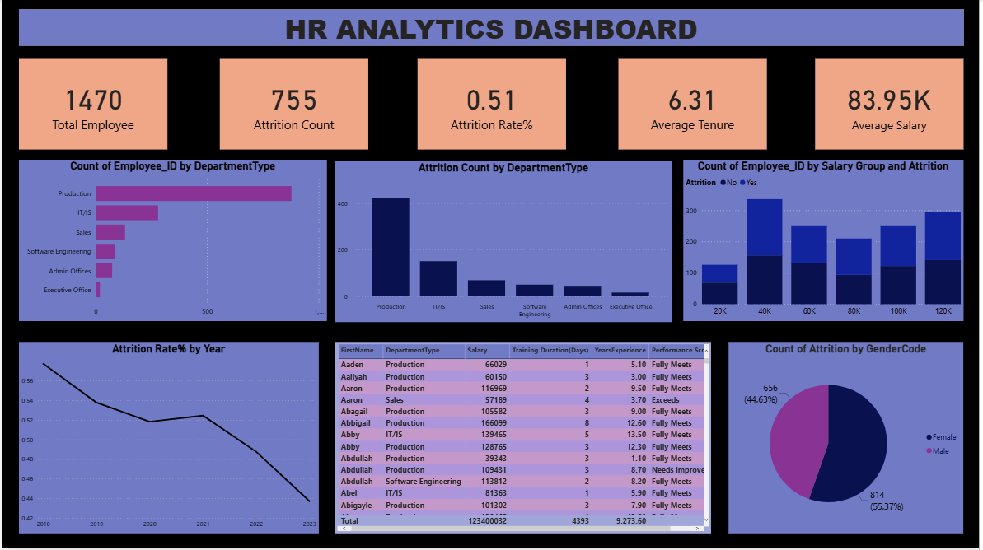

**7.Visuals**

**KPI cards: Total Employees, Attrition Count, Attrition Rate, Avg Salary, Avg Tenure**

**Bar chart: Employee Count by Department**

**Column charts: Attrition Count by Department,Count of EmpIoyee_ID by Salary Group and Attrition**

**Line Chart:Attrition rate by Year**

**Table: Detailed employee list for drill-down**

**Pie Chart:Attrition count by gender code**

**8.Key Insights**

**Production department has highest attrition rate.**

**Employees doing overtime are 2x more likely to leave.**

**Higher training hours = lower attrition.**